Running crosstab queries for annual statistics.
(Item counts by Location and Format Type)

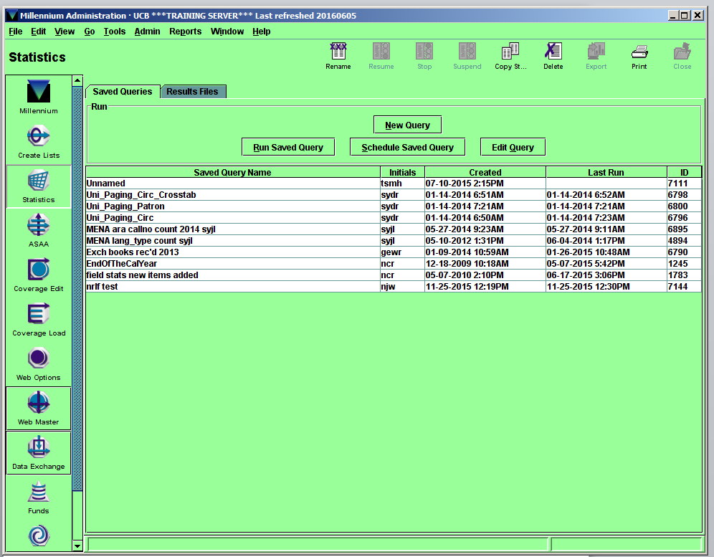
In Millennium Statistics Module choose “New Query.”

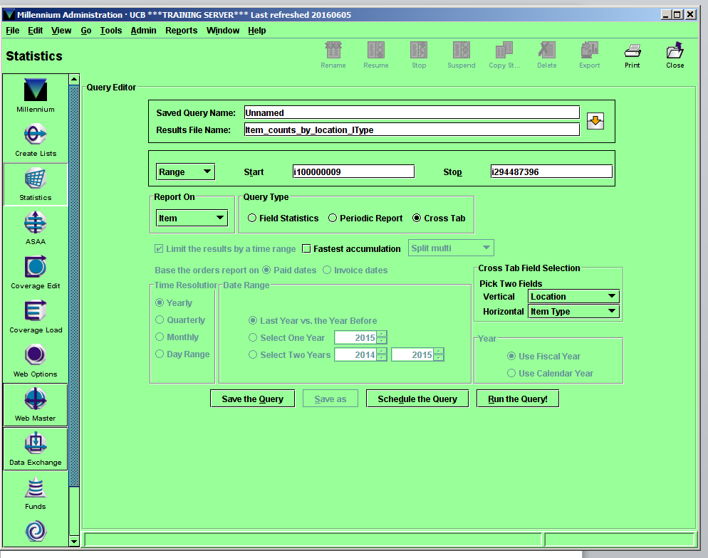
Enter a file name in the “Results File Name.” The “Saved Query Name” can be left as-is. Later, when prompted about whether you want to save the query, just say no. 1. For full database crosstab, choose “Item” as the file type in “Report On” and make sure that the module is set to look for a range of item numbers. 2. To run statistics against a review file, make sure the module is set to look for review files.
Choose “Location” as the vertical field and “Item Type” as the horizontal file type under “Cross Tab Field Selections.” Click “Run the Query!” Two dialog boxes will pop up before the query actually runs. Click “ok” to the first, and “yes” to the second.
The query for these statistics will run for a long time, a few hours.

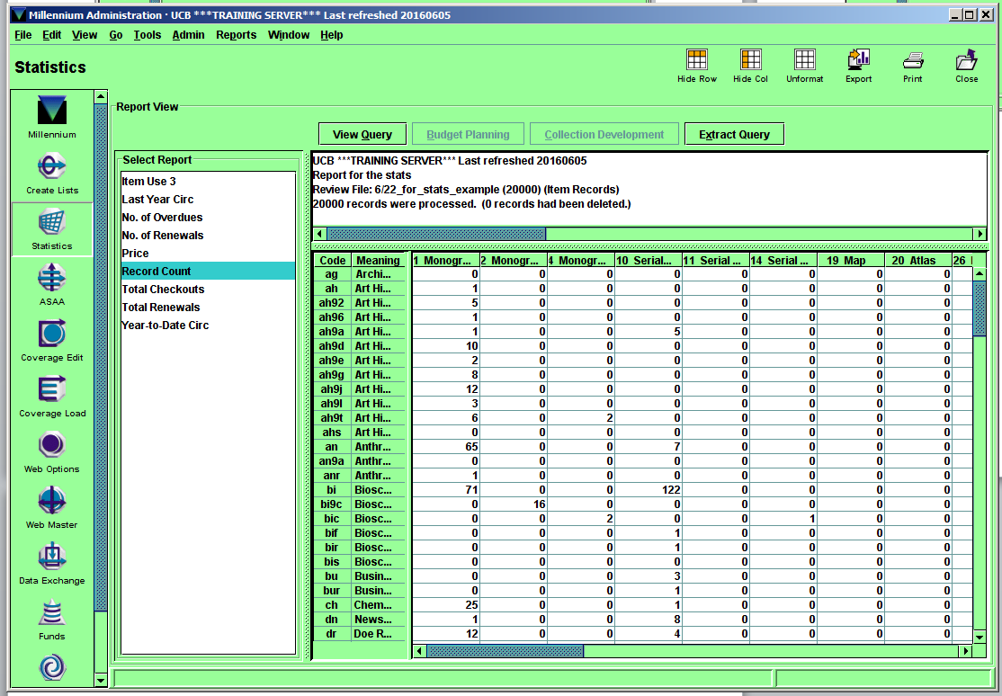

Once the query is finished, select the query in the “Results Files” tab and then “View Report.” On the left hand side of the report view pane there is an option to select various reports (“Select Report). Select “Record Count.” At the top right of the report view pane select the “Export” button.

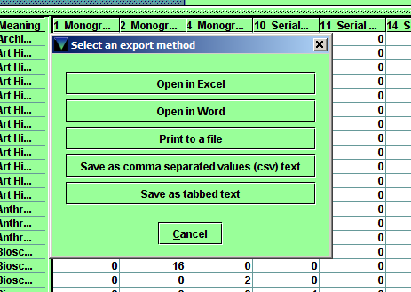

Select “Open in Excel” and the report should now be in an Excel format. Save to the directory you plan to work from.

In all output Excel files, delete the header that is automatically generated by Millennium. Delete rows 1-5, so that the heading is now the iTypes, row 6 is now row 1.
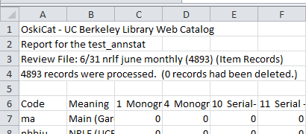

The scripts in numbers 5 through 7 of “Item counts by Locationa dn Format Type” can now be run against these 4 worksheets.

